Fish Tank Monitor

Savannah Tanner, Caleb Neill, Astrid Delestine

11/29/2023

Table of Contents

**Executive Summary 4**

**1 Fish Tank Monitor Overview 5**

1.1 Description 6

1.2 Team Contacts and Protocols 7

1.2.1 Diversity, Equity, and Inclusion Statement 7

1.2.2 Communication Analysis 8

1.3 Gap Analysis 9

1.4 Timeline and Task List 10

1.5 References and File Links 11

1.5.1 References 11

1.5.2 File Links 11

1.6 Revision Table 12

**2 Impacts and Risks 13**

2.1 Design Impact Statement 13

2.2 Risks 14

2.3 References and File Links 16

2.3.1 References 16

2.3.2 File Links 16

2.4 Revision Table 17

**3 Top-Level Architecture 18**

3.1 Block Diagram 18

3.2 Block Descriptions 19

3.3 Interface Definitions 21

3.4 References and File Links 23

[3.4.1 References  
[1] D. Heer, ECE Senior Design,   
 https://eecs.engineering.oregonstate.edu/capstone/ece/student/   
 (accessed Dec. 4, 2023). 23](#_rgjq9z4wgw8u)

3.4.2 File Links 23

3.5 Revision Table 24

**4 Block Validations 25**

4.X Block Name 25

4.X.1 Desciption 25

4.X.2 Design 25

4.X.3 General Validation 25

4.X.4 Interface Validation 25

4.X.5 Verification 25

4.X.6 References and File Links 25

4.X.6.1 References 25

4.X.6.2 File Links 26

4.X.7 Revision Table 26

**5 System Verification Evidence 27**

5.1 Universal Constraints 27

5.1.1 The system may not Include a breadboard 27

5.1.2 The final system must contain a student-designed PCB 27

5.1.3 All connections to PCBs must use connectors 27

5.1.4 All power supplies in the system must be at least 65% efficient 27

5.1.5 The system may be no more than 50% built from purchased 'modules' 27

5.2 Requirements 28

5.2.1 Test Strip Reading 28

5.2.1.1 Project Partner Requirement 28

5.2.1.2 Engineering Requirement 28

5.2.1.3 Testing Method 28

5.2.1.4 Verification Process 28

5.2.1.5 Testing Evidence 28

5.2.2 Display 28

5.2.2.1 Project Partner Requirement 28

5.2.2.2 Engineering Requirement 28

5.2.2.3 Testing Method 28

5.2.2.4 Verification Process 28

5.2.2.5 Testing Evidence 29

5.2.3 Logging and File Export 29

5.2.3.1 Project Partner Requirement 29

5.2.3.2 Engineering Requirement 29

5.2.3.3 Testing Method 29

5.2.3.4 Verification Process 29

5.2.3.5 Testing Evidence 29

5.2.4 User Interface 29

5.2.4.1 Project Partner Requirement 29

5.2.4.2 Engineering Requirement 29

5.2.4.3 Testing Method 29

5.2.4.4 Verification Process 29

5.2.4.5 Testing Evidence 30

5.2.5 Feeding and Cleaning Schedule 30

5.2.5.1 Project Partner Requirement 30

5.2.5.2 Engineering Requirement 30

5.2.5.3 Testing Method 30

5.2.5.4 Verification Process 30

5.2.5.5 Testing Evidence 30

5.2.6 Dangerous Parameter Alerts 30

5.2.6.1 Project Partner Requirement 30

5.2.6.2 Engineering Requirement 30

5.2.6.3 Testing Method 30

5.2.6.4 Verification Process 31

5.2.6.5 Testing Evidence 31

5.2.7 User Defined Parameter Ranges 31

5.2.7.1 Project Partner Requirement 31

5.2.7.2 Engineering Requirement 31

5.2.7.3 Testing Method 31

5.2.7.4 Verification Process 31

5.2.7.5 Testing Evidence 31

5.2.8 User Defined Parameter Ranges 31

5.2.8.1 Project Partner Requirement 31

5.2.8.2 Engineering Requirement 31

5.2.8.3 Testing Method 32

5.2.8.4 Verification Process 32

5.2.8.5 Testing Evidence 32

5.3 References and File Links 33

5.3.1 References 33

5.3.2 File Links 33

5.4 Revision Table 34

# Executive Summary

Our project is an all-in-one fish tank monitor. It will consist of multiple internal sensors and a system to log water parameter paper test results and display them in an organized form. We are aiming to make the product inexpensive and user-friendly to ensure that all fish hobbyists can feel comfortable managing their fish tank’s array of parameters.

The monitor will track a variety of parameters including the level of nitrites, nitrates, ammonia, salinity, pH, temperature, and luminosity index. It will also include a feeding and cleaning schedule function and log test results. These test results will be exportable through a micro-USB. The device will test various parameters with a color sensor and testing strips, allowing the device to allow for further accessibility. The user interface will consist of a screen with a series of buttons so that all users can easily navigate their options and care for their tank appropriately.

# 1 Fish Tank Monitor Overview

In this Fish Tank Monitor project, Savannah Tanner, Caleb Neill, and Astrid Delestine are collaboratively developing an all-in-one monitoring system tailored for aquarium enthusiasts. This device includes internal sensors that track key parameters such as nitrites, nitrates, ammonia, salinity, pH, temperature, and lux. Some practical features include a feeding and cleaning schedule, and the ability to log test results, exportable through a micro-USB connection. The user interface is designed for easy navigation with a screen and intuitive buttons. The team places a strong emphasis on inclusivity, aiming to provide an accessible product for fish enthusiasts from diverse backgrounds.

Communication within the team is facilitated through regular meetings and a dedicated Discord server, and documentation is centralized in a shared Google Drive folder. The gap analysis reveals a market need for a comprehensive and affordable solution, as existing products often require multiple devices for testing. The Fish Tank Monitor project seeks to address this gap by offering a single integrated system, making fish tank maintenance more accessible.

## 1.1 Description

This team, consisting of Astrid Delestine, Caleb Neil, and Savannah Tanner has created a device for our senior capstone project at Oregon State University. Our fish tank monitoring system is designed to track and log aquarium parameters including the presence of nitrites, nitrates, and ammonia as well as the pH, temperature, lux, and salinity levels. The system provides real-time alerts for poor water quality, feeding, and cleaning. The device includes a user-friendly interface to help aquarium hobbyists track the health of their tank daily as well as over time. Once installed, this system will reduce the need for manual testing and combine several analysis methods into a single device, enhancing the overall experience for fish enthusiasts. This device is being developed over the course of three quarters of a year, to fill an observed hole in the market.

## 1.2 Team Contacts and Protocols

Savannah Tanner: [tannersa@oregonstate.edu](mailto:tannersa@oregonstate.edu)

Caleb Neill: [neillca@oregonstate.edu](mailto:neillca@oregonstate.edu)

Astrid Delestine: [delestic@oregonstate.edu](mailto:delestic@oregonstate.edu)

**Team Protocols:**

| Topic | Protocol | Standard |
| --- | --- | --- |
| Time management | We will meet once or more each week | The Google Drive meetings folder will have meeting notes for each week |
| Task management | We will divide the work for assignments evenly | All work will be complete and each team member will have completed an equal portion of the work |
| Communication | We will use a team Discord server for all team communication not in-person | All project-related discussions will occur in a dedicated Discord server so that the conversations can be accessed later |
| On-time deliverables | All assignment drafts will be completed by a pre-set deadline to ensure the team can review them before submission | Submissions will never be late unless discussed within the team and a record made of the discussion in either Google Drive or the Discord server |
| Documentation | All documentation will be stored in the shared Google Drive folder and organized appropriately | The Google Drive will contain documentation for everything we research and use in our project |

### 1.2.1 Diversity, Equity, and Inclusion Statement

The Fish Tank Monitor Project is committed to fostering a sense of diversity, equity, and inclusivity. We prioritize equitable design and accessibility, seeking to design our project with all backgrounds and resources in mind. We value diverse opinions and various perspectives for collaboration. We strive to ensure we are providing equal opportunities and experiences to create a product that is accessible and fair to all. DEI is an integral part of our project, ensuring that our work benefits all who care for aquatic life.

### 1.2.2 Communication Analysis

The target market for this product would include fish tank hobbyists, fish sellers, and large-scale aquarium owners. The hobbyists may have less technical expertise than fish sellers so the communication should be concise and free of most technical jargon. Regular communication through email is preferred so that they can be updated on project improvements as they are made. Retailers and fish sellers are interested in the product’s pricing, marketing materials, and availability. They may also lack certain technical expertise so communication should remain free of technical jargon but include more information about the advancements of the product from a marketing standpoint. Large-scale aquarium owners would require updates on the capabilities of the product and the scale at which it is operational. Larger aquariums require different varieties of testing, so this would mean updates similar to those of the hobbyists.

## 1.3 Gap Analysis

Maintaining a healthy fish tank environment requires testing various parameters on a regular basis. Each of these tests must be done in order to ensure that the water is safe for aquatic organisms to survive. Despite the need for this testing, there are no products available to fish tank hobbyists which accurately test a large number of parameters at once and compile the information so that users can keep track of the health of their aquarium while being inexpensive. For instance, the company Seneye is known for its fish tank monitoring systems which continuously track water parameter changes, but the only parameters that the system tests are pH, ammonia, and temperature [4]. Regular testing should include testing for pH, ammonia, temperature, nitrites, nitrates, hardness, and chlorine [5]. This is because producing a sensor to test for a single parameter requires complex calibration as the sensors are detecting chemical changes in the water [3]. Fish tank hobbyists often have to spend hundreds of dollars on devices and tools for testing and then using all of these devices on a regular basis. As such, the hobby becomes difficult and fewer people are interested. By creating a product which can conduct a variety of tests in a single integrated system without requiring user interaction, keeping a healthy fish tank becomes easy, convenient, and cost effective.

## 1.4 Timeline and Task List

Depicted below is our expected timeline for this project.

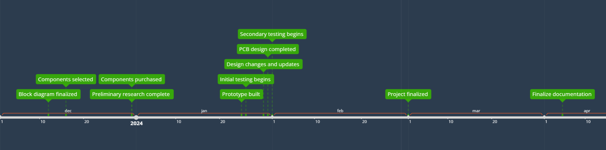

Task Timeline

**Task List:**

| **Task Description** | **Impact Risk** | **Expected Hours** | **Due Date** | **Champion** | **Actual Work Hours** | **Assigned** |
| --- | --- | --- | --- | --- | --- | --- |
| initial user interface design | 8 | 3 | 10/31 | Savannah | 5 | Savannah |
| selecting screen | 8 | 1 | 11/15 | Savannah | 1 | Savannah |
| Color Sensor Picking | 7 | 1 | 11/3 | Astrid | 1 | Astrid |
| Finalize UI V1 | 6 | 2 | 11/8 | Savannah | 1 | Savannah |
| ESP32: buttons interaction | 7 | 1+ | 11/27 |  |  | Caleb |
| ESP32: color sensor interaction | 8 | 1+ | 11/27 |  |  | Astrid |
| ESP32: temp sensor interaction | 8 | 1+ | 11/27 |  |  | Caleb |
| ESP32: screen interaction | 8 | 1+ | 11/27 |  |  | Savannah |
| Shared Schematic Implementation | 8 | 1+ | 11/6 | Astrid | 1 | Astrid |
| Initial CAD work | 7 | 3 | HOLD |  | 1+... | Astrid |
| Determine test strip method | 7 | 4 | 11/24 |  |  | Caleb |
| Test UI on 3 subjects | 7 | 3 | 11/27 |  |  | Savannah |
| Market research | 6 | 3+ |  |  |  | All |
| Develop early sensor pseudocode | 5 | 3+ | 12/1 |  |  | Savannah |
| Alter UI for rectangle screen | 7 | 2 | 12/1 |  |  | Savannah |
| Determine test strip parts | 7 | 2 | 12/1 |  |  | Caleb |
| remake the timeline | 4 | 1 | 11/24 |  |  | Savannah |

## 1.5 References and File Links

### 1.5.1 References

[1] AlfredH1 and Instructables, “Everything you need to know about colour sensors,” Instructables, <https://www.instructables.com/Everything-you-need-to-know-about-colour-sensors/>, (accessed Oct. 19, 2023).

[2] “Detection based on ‘light’what is a color sensor?,” KEYENCE, https://www.keyence.com/ss/products/sensor/sensorbasics/color/info/, (accessed Oct. 19, 2023).

[3] "Ammonium & Ammonia sensors for water testing,” AquaRead, https://www.aquaread.com/sensors/ammonium-ammonia (accessed Nov. 12, 2023).

[4] “Seneye,” seneye, https://www.seneye.com/ (accessed Nov. 12, 2023).

[5] “How (and how often) to test aquarium water for healthy fish and plants,” Op, https://www.aquariumcoop.com/blogs/aquarium/aquarium-water-testing (accessed Nov. 12, 2023).

### 1.5.2 File Links

[ESP32 Datasheet](https://drive.google.com/file/d/1LZmSpgBcTSkA72qA32ZNZrJ2Q4c14Vzr/view?usp=share_link)

[Color Sensor Notes](https://docs.google.com/document/d/1tmPK-S2oo9aXApMzLYQliIJt_JYLfn_S148TjRFearc/edit?usp=sharing)

## 1.6 Revision Table

| Date | Action |
| --- | --- |
| 11/29/2023 | Savannah Tanner: updated timeline |
| 11/22/2023 | Astrid Delestine: Made small updates to word choice and sentence structure, updated task list. |
| 11/12/2023 | Caleb Neill: Revised overview paragraphs |
| 11/12/2023 | Savannah Tanner: team contacts, protocols |
| 11/12/2023 | Savannah Tanner: gap analysis edits |
| 11/12/2023 | Astrid Delestine: description, gap analysis edits |
| 10/19/2023 | Savannah Tanner, Caleb Neill, Astrid Delestine: section 1 draft completion |
| 10/19/2023 | Savannah Tanner: initial document creation |

# 2 Impacts and Risks

## 2.1 Design Impact Statement

**Note: Impact assessment underway. Please request additional information if needed.**

*Section to be created in Spring using a summary of our completed design impact assessment.*

## 2.2 Risks

**Risks and Action Plans:**

| **Risk ID** | **Risk Description** | **Risk Category** | **Risk Probability** | **Risk Impact** | **Action Plan** |
| --- | --- | --- | --- | --- | --- |
| 1 | Team member needs to take personal time unexpectedly | Organizational | M | M | Team member informs group as soon as possible, group forms a plan to ensure work can be completed effectively, group informs professors about the situation |
| 2 | ordering PCB during Chinese New Year through China-based company | Organizational | M | H | Avoid purchasing from China-based companies around Chinese New Year |
| 3 | water leaks into system | Safety | M | H | disconnect the device from power and remove it from the tank then locate and repair the leak |
| 4 | team member misses a deadline | Organizational | H | M | alert the team member about the deadline and meet to plan how to avoid this in the future; to avoid this we will discuss all deadlines during weekly meetings |
| 5 | wrong materials are used that are unsafe for aquatic life | Environmental/safety | M | H | Remove the device from the tank and replace the material; to avoid this we will ensure all materials are safe for aquatic life before using them |
| 6 | system goes over budget | Organizational | H | M | re-evaluate our budget and components and, if necessary, seek to expand our budget |
| 7 | sensors are reading incorrectly | Technology | M | H | test the sensors with known values and re-calibrate; if the sensors are not working properly and the issue does not stem from any software problems, seek replacements |
| 8 | Mechanical wear and tear | Technology | M | M | Dedicate a segment of time todo long term testing to make sure it doesn't fail within a reasonable number of tests |

## 2.3 References and File Links

### 2.3.1 References

[1] C. Lau, “Chinese New Year 2023: Have you prepared your PCB orders?,” *PCB   
 Connect Group*, Oct. 11, 2022.   
 https://www.pcbconnectgroup.com/chinese-new-year-2023-have-you-prepared-  
 your-pcb-orders/ (accessed Nov. 12, 2023).  
[2] “Plastics Leach More Toxins Into the Water Than Previously Known,” *The Maritime  
 Executive*.   
 https://maritime-executive.com/editorials/plastics-leach-more-toxins-into-the  
 -water-than-previously-known#:~:text=All%20of%20the%20products%20  
 leached%20chemicals%20into%20the (accessed Nov. 13, 2023).

### 2.3.2 File Links

[Types of materials that would be safe for aquarium use](https://docs.google.com/document/d/1fMSwbjMEzXV5rulFBDCrEdgdNqxRAWWHuxoPyYMSAGM/edit?usp=sharing)

## 2.4 Revision Table

| Date | Action |
| --- | --- |
| 11/22/2023 | Caleb Neill: added 8th risk to Risk Table |
| 11/21/2023 | Savannah Tanner: Updated section 2 based on TA comments (capitalization in risks and actions table, removed bold font in references) |
| 11/12/2023 | Astrid Delestine: References to Risk Table |
| 11/12/2023 | Savannah Tanner: risk table added |
| 11/12/2023 | Astrid Delestine:   * Header and page numbers * Rachels's suggestions for * Overview * Gap Analysis |
| 11/12/2023 | Savannah Tanner: section 2 created |

# 3 Top-Level Architecture

## 3.1 Block Diagram

Black Box Diagram

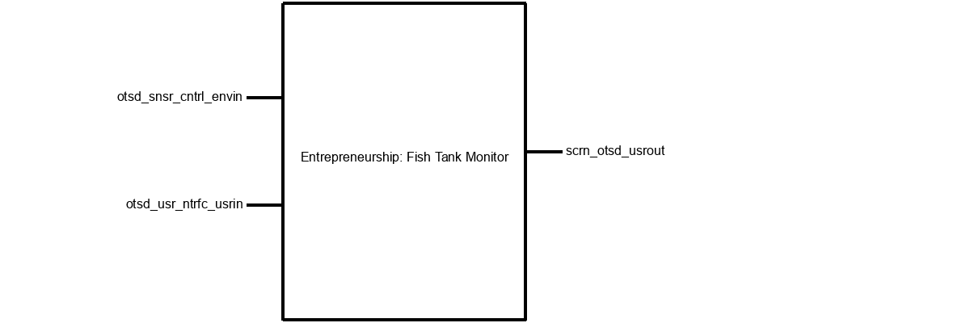

Block Diagram

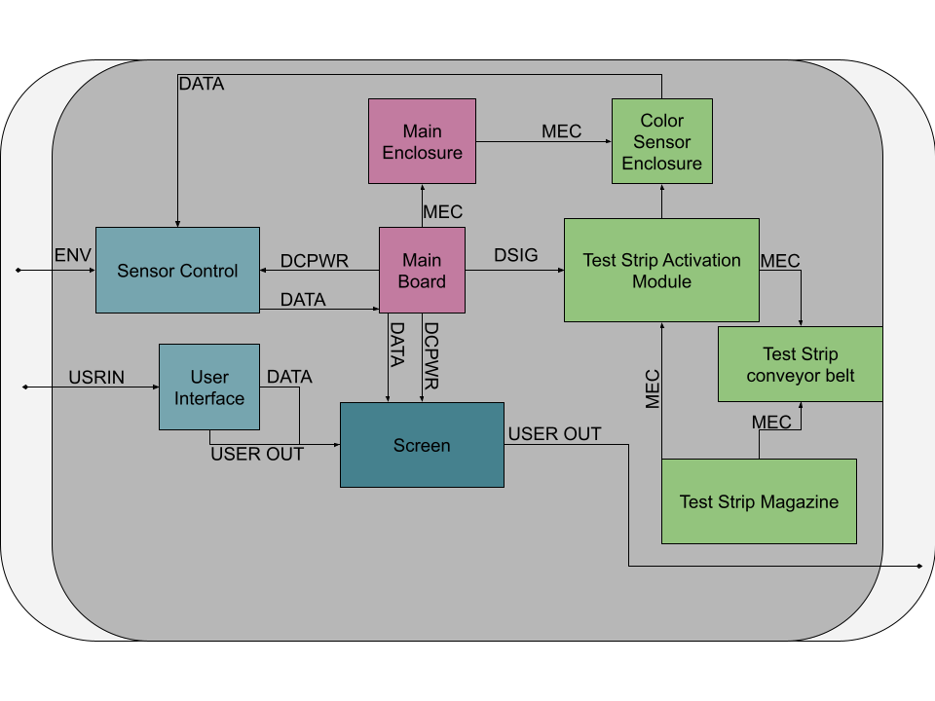

## 3.2 Block Descriptions

Block Descriptions

| **Name** | **Description** |
| --- | --- |
| Sensor Control  Champion: Savannah Tanner | The module is responsible for controlling, interpreting, and managing the color sensor. This module interprets the results collected with the color sensor and communicates these results to the main board for processing. |
| Main Board  Champion: Astrid Delestine | The module is responsible for connecting all the various electrical components. It contains the code and screen data. |
| Test Strip Conveyor Belt  Champion: Caleb Neill | The module is responsible for moving the test strip from module to module for processing and sensing. This module is split into dry and wet conveyors to reduce water getting into Test Strip Magazine. |
| Color Sensor Enclosure  Champion: Caleb Neill | The module is responsible for holding the color sensor and absorbing light from outside sources. It is fed from the Test Strip Activation Module and is dispensed out of the system. |
| Screen  Champion: Savannah Tanner | The visual output interface used by the system. The screen displays test results, system statuses, and prompts the users to complete different tasks for maintaining a healthy aquarium. The screen provides a means for users to interact with and interpret data collected by the fish tank monitor. |
| Main Enclosure  Champion: Astrid Delestine | The main enclosure protects the main board, the sensor control, and the screen. Due to the nature of the proximity to water, this is necessary. This enclosure cannot block user access to the screen. |
| User Interface  Champion: Savannah Tanner | The user-facing component that allows for user-interaction with the fish tank monitor. This includes buttons and on-screen pages that bridge between the user and the fish tank monitor's technology. |
| Test Strip Magazine  Champion: Caleb Neill | The Test Strip Magazine is responsible for holding all test strips currently not being tested, it interacts with the Test Strip Conveyor and must be kept separate from all water. |
| Test Strip Activation Module  Champion: Caleb Neill | The Activation Module is where the test water is dispensed onto the test strips. It is crucial that all excess water drains out into the tank and does not come in contact with the test strip magazine. |

## 3.3 Interface Definitions

Interface Definitions

| **Name** | **Properties** |
| --- | --- |
| otsd_snsr_cntrl_envin | Electromagnetic: wavelength range  Light: intensity  Temperature (Absolute): temperature of water measured |
| otsd_usr_ntrfc_usrin | Other: interrupt based  Type: multi-directional  Type: button pushes |
| mn_nclsr_clr_snsr_nclsr_mech | Fasteners: friction  Other: material: PETG  Shear Force: >1N |
| mn_brd_snsr_cntrl_dcpwr | Inominal: 210 uA  Ipeak: 300 uA  Vmax: 2.0v  Vmin: 1.7v |
| mn_brd_scrn_data | Datarate: 400 kbit/s  Messages: main board sends data to screen to be displayed to the user (these consist of numerical values measuring various water parameters)  Protocol: I2C |
| mn_brd_scrn_dcpwr | Inominal: 1A  Ipeak: 1.2A  Vmax: 5v  Vmin: 3.3v |
| mn_brd_tst_strp_ctvtn_mdl_dsig | Other: I2C  Vmax: 3.3v  Vmin: -.02v |
| snsr_cntrl_mn_brd_data | Datarate: 400 kbit/s  Messages: sensor sends color data (in hex form) to board to be interpreted into water parameter values based on the test strip color key  Protocol: I2C |
| usr_ntrfc_scrn_usrout | Other: paper-like  Type: Screen output consists of graphs, lists, numbers, text, and illustrations (all of which are depicting some information about the aquarium's water parameters)  Usability: Output must be useful and usable, must be understandable by 9/10 users |
| usr_ntrfc_scrn_data | Datarate: 400 kbit/s  Messages: user interface tells screen what to display depending on user input through buttons. Displays screens with graphs, illustrations, lists, text, and numbers.  Protocol: I2C |
| scrn_otsd_usrout | Other: black and white screen  Type: paper-like screen  Usability: understood by 9/10 users |
| clr_snsr_nclsr_snsr_cntrl_mech | Fasteners: clips  Other: temp < 230 C  Other: MAT PETG |
| tst_strp_mgzn__tst_strp_cnvyr_blt_mech | Other: temp: < 230 C  Other: material: PETG  RPM: 1 rpm |
| tst_strp_mgzn__tst_strp_ctvtn_mdl_mech | Other: Type: friction  Other: material: PETG  Other: Wear: Water |
| tst_strp_ctvtn_mdl_tst_strp_cnvyr_blt_mech | Other: hydo:Y  Other: mat:petg  Other: type: friction |
| tst_strp_ctvtn_mdl_clr_snsr_nclsr_mech | Fasteners: Clips  Pulling Force: -0.000001  Shear Force: 0.000001 |

## 

## 3.4 References and File Links

### 3.4.1 References [1] D. Heer, ECE Senior Design, https://eecs.engineering.oregonstate.edu/capstone/ece/student/ (accessed Dec. 4, 2023).

### 3.4.2 File Links

## 3.5 Revision Table

| Date | Action |
| --- | --- |
| 12/4/2023 | Caleb Neill: updated tables |
| 12/4/2023 | Astrid Delestine: added finalized block diagram |
| 12/4/2023 | Savannah Tanner: added interface definitions, added block definitions |
| 11/29/2023 | Savannah Tanner: section 3 creation |

# 4 Block Validations

## 4.X Block Name

### 4.X.1 Desciption

This section gives a 1-2 paragraph description of what this block accomplishes for the system and what it contains.It must be identical to the information for this block in the online block diagram tool on the student portal.

### 4.X.2 Design

This section presents the contents of the block. This varies based on the block but something graphical is recommended and in most cases required. Schematics of the block contents (not reference design), wiring diagrams for modules, flowcharts, state diagrams, mechanical drawings, etc... Do not include final code here (that should be in the File Links section) but instead present a higher level code flow.

### 4.X.3 General Validation

This section is multiple paragraphs that explain why whatever you included in the Design section meets the needs of the system and will work.

### 4.X.4 Interface Validation

This section must be a table format with the required columns. It needs to match the interface properties listed in section 3 and in the online block diagram tool. For each interface property this section needs to prove why the property is the value indicated, and how the block is known to meet the property fully. This section is expected to have lots of references.

### 4.X.5 Verification

Since each block is required to be shown to meet the interfaces as described, this section will contain the process that will be used to verify the block is functioning correctly. This process should be numbered steps and should be able to be completed by an ECE student not familiar with your block. Once a block is proven, this section will also contain evidence of the success of the block.

### 4.X.6 References and File Links

#### 4.X.6.1 References

This section should contain links to external references in IEEE format. These references only pertain to the contents of section 3, and no other sections.

#### 4.X.6.2 File Links

This section should contain links to any files/artifacts your team has produced that are important to the information provided in this section. They should be hyperlinked with descriptive text that links to an accessible file location. Be sure any files linked here have proper permissions for readers to be able to access them. These links only pertain to the contents of the section they belong to.

### 4.X.7 Revision Table

| Date | Action |
| --- | --- |
| 12/6/2023 | Caleb Neill: added X Block Validation (4.X) |

# 

# 5 System Verification Evidence

## 5.1 Universal Constraints

### 5.1.1 The system may not Include a breadboard

The Fish Tank Monitor project adheres to the constraint by excluding the use of a breadboard in its design and ensuring that all connections are made directly between PCBs and components

### 5.1.2 The final system must contain a student-designed PCB

The Fish Tank Monitor project adheres to the constraint by incorporating a student-designed PCB as an integral part of the final system, serving as a central platform to host the various components necessary for the system's operation.

### 5.1.3 All connections to PCBs must use connectors

The Fish Tank Monitor project adheres to the constraint by using connectors for all connections between PCBs and components. This enhances modularity, ease of assembly and disassembly, and allows for alterations.

### 5.1.4 All power supplies in the system must be at least 65% efficient

The Fish Tank Monitor project adheres to the constraint by ensuring that all power supplies maintain the minimum efficiency requirement of 65%. The design prioritizes energy efficiency to enhance the sustainability and performance of the system.

### 5.1.5 The system may be no more than 50% built from purchased 'modules'

The Fish Tank Monitor project adheres to the constraint by ensuring that no more than half of all modules used in the system were pre-purchased rather than designed by the team.

## 5.2 Requirements

### 5.2.1 Test Strip Reading

#### 5.2.1.1 Project Partner Requirement

The system must be capable of performing water parameter tests without user interference

#### 5.2.1.2 Engineering Requirement

The system will read and report the results of an aquarium parameter test strip every 7 days

#### 5.2.1.3 Testing Method

The requirement will be tested via demonstration

#### 5.2.1.4 Verification Process

The results collected by the system will be compared to the results obtained by comparing the aquarium parameter test strip tested by the system to the color key provided with the test strips

The results found by the system will match those found manually within a 10% error rate for all tested parameters

#### 5.2.1.5 Testing Evidence

TBD

### 5.2.2 Display

#### 5.2.2.1 Project Partner Requirement

The results of the tests must be accessible to the user within the system

#### 5.2.2.2 Engineering Requirement

The system will have a screen which displays parameter test results following each test

#### 5.2.2.3 Testing Method

Demonstration

#### 5.2.2.4 Verification Process

After a water parameter test has been run by the system, the screen will display the results of the test within 30 seconds of the test's completion

## 5.2.2.5 Testing Evidence

TBD

### 5.2.3 Logging and File Export

#### 5.2.3.1 Project Partner Requirement

Test results must be accessible after outside of the system

#### 5.2.3.2 Engineering Requirement

The system will save test results to an exportable memory device

#### 5.2.3.3 Testing Method

Test

#### 5.2.3.4 Verification Process

The user will select the option to remove the memory device; once the device indicates it is safe to remove the memory device, the user may remove it and insert the device into a personal computer; the memory device will store up to a year's worth (52 entries) of data which can be accessed through files in the device's memory

Up to a year's worth of data will be stored on the device and is accessible on a PC

## 5.2.3.5 Testing Evidence

TBD

### 5.2.4 User Interface

#### 5.2.4.1 Project Partner Requirement

The system must provide a consistent and intuitive experience across all functionalities

#### 5.2.4.2 Engineering Requirement

9/10 users can navigate the graphical user interface of the system without formal instruction

#### 5.2.4.3 Testing Method

Inspection

#### 5.2.4.4 Verification Process

Users will interact with all pages of the user interface to assess the consistency and intuitiveness of the design without formal training

No buttons or links lead to errors or missing pages

9/10 users complete key tasks without requiring additional assistance

## 5.2.4.5 Testing Evidence

TBD

### 5.2.5 Feeding and Cleaning Schedule

#### 5.2.5.1 Project Partner Requirement

Users should be able to effortlessly keep track of their fish feeding and tank cleaning habits

#### 5.2.5.2 Engineering Requirement

The system will allow users to define and customize feeding and cleaning schedules

#### 5.2.5.3 Testing Method

Inspection

#### 5.2.5.4 Verification Process

Users will access the scheduling feature; create/modify/delete feeding and cleaning schedules;

The scheduling feature is present and functional within the user interface and updates to these schedules are maintained

## 5.2.5.5 Testing Evidence

TBD

### 5.2.6 Dangerous Parameter Alerts

#### 5.2.6.1 Project Partner Requirement

The system should alert users to dangerous water parameters to maintain a healthy environment

#### 5.2.6.2 Engineering Requirement

The system shall display an alert on the screen when a tested water parameter is outside of bounds set by the user

#### 5.2.6.3 Testing Method

Test

#### 5.2.6.4 Verification Process

A sample of water with its parameters outside of the pre-set bounds will be tested by the system and the system will report the results of the test, resulting in a warning alert to the user displayed on screen

The system displays a warning identifying which parameter must be addressed

## 5.2.6.5 Testing Evidence

TBD

### 5.2.7 User Defined Parameter Ranges

#### 5.2.7.1 Project Partner Requirement

Users must be able to specify the acceptable ranges for various parameters to suit their aquarium's needs

#### 5.2.7.2 Engineering Requirement

9/10 users will be able to adjust the ranges of all parameters that are deemed safe for their aquarium

#### 5.2.7.3 Testing Method

Demonstration

#### 5.2.7.4 Verification Process

The demonstrator will alter the parameter ranges for all water parameters tested by the system and test water within and outside of the newly updated ranges

Only water that no longer falls into the acceptable ranges will cause warnings

## 5.2.7.5 Testing Evidence

TBD

### 5.2.8 User Defined Parameter Ranges

#### 5.2.8.1 Project Partner Requirement

Users should have the ability to maintain a comprehensive list of all fish and organisms living in their aquarium

#### 5.2.8.2 Engineering Requirement

The system will maintain a list of creatures present in the aquarium

#### 5.2.8.3 Testing Method

inspection

#### 5.2.8.4 Verification Process

The user will navigate to the inhabitants list page where they can interact with the interface to add and remove inhabitants

The inhabitants list maintains all saved data inputted by the user

## 5.2.8.5 Testing Evidence

TBD

## 5.3 References and File Links

### 5.3.1 References

### 5.3.2 File Links

[List of Project Requirements](https://docs.google.com/document/d/14z5ZMwlRsYde8bqgRMFZ-tYWEEa3KpGjSAcDxyz3wkM/edit?usp=sharing)

## 5.4 Revision Table

| Date | Action |
| --- | --- |
| 12/4/2023 | Savannah Tanner: requirements added (section 5.2), universal constraints added (section 5.1), file links added (section 5.3.2) |
| 11/29/2023 | Savannah Tanner: section 5 created |